1. Can you hear the difference between the just tempered Major chord and the equal tempered Major chord?
   1. Using the additive “bell” sound, a difference is slightly audible – the equal tempered major chord sounds as though there is a slight hint of beats, whereas the just tempered chord sounds more “hollow,” roughly speaking. Looking at the sound waves over time, a slight crest is visible around the 2x104-samples mark on the equal tempered chord; the just tempered chord has a smoother die-off instead.
2. Which one sounds better? - Why (explain)
   1. I prefer the just tempered chord, as its “hollow” ringing sounds more natural than the ringing undertones of the equal tempered chord.

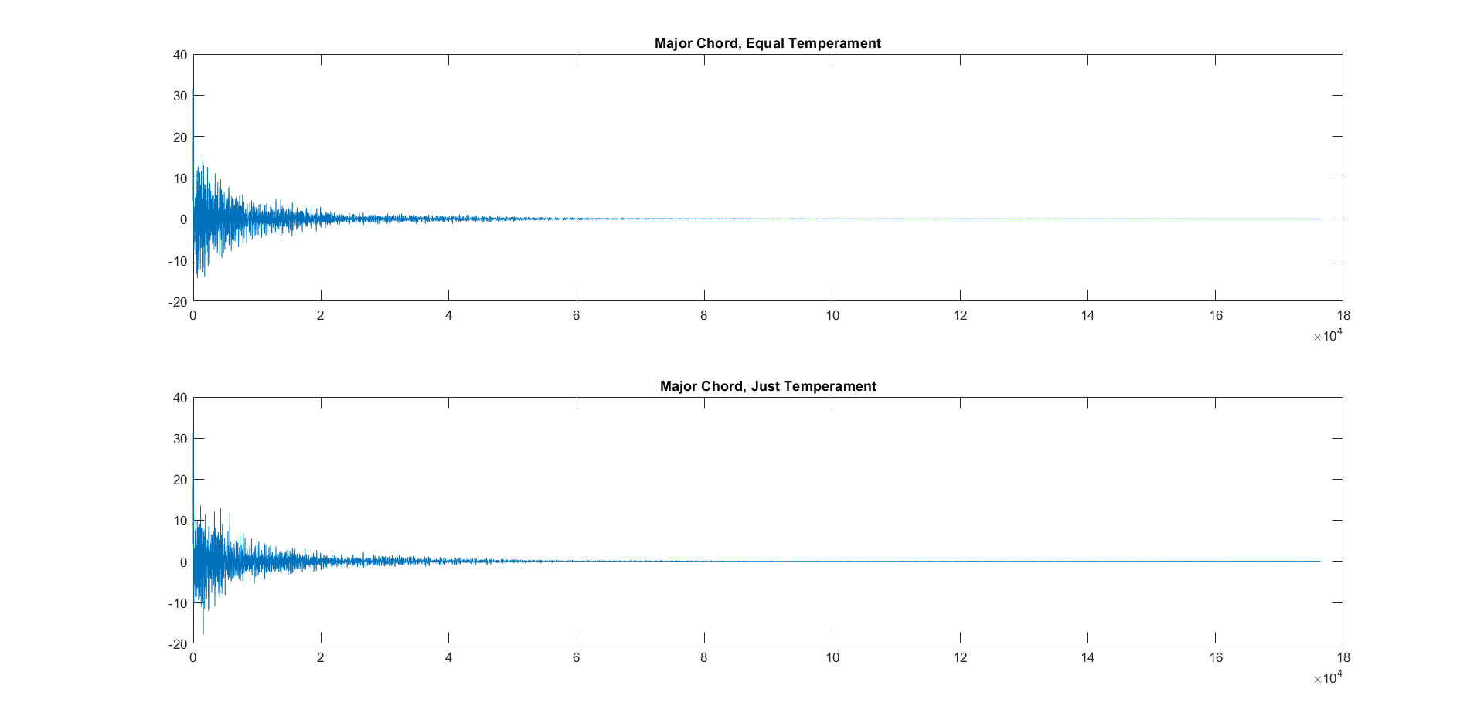

1. Can you hear the difference between the just tempered Minor chord and the equal tempered Minor chord?
   1. A slight difference is again audible, but less noticeably than the difference between the major chords. Once again, the just tempered chord sounds slightly richer and more realistic (once again “hollower”) than the equal tempered chord. In the plots of the signals, there is a slight bump is visible around the 1.75x104-samples mark on the equal tempered chord that is not present in the plot of the just tempered chord.
2. Which one sounds better? - Why (explain)
   1. Just as with the major chords, the just tempered chord sounds more realistic and therefore more pleasing than the equal tempered chord.

